
RARITY IG — Content Idea Brief: The Platform You're Skipping
2026-09-13 · Growth Marketing & Branding · STATIC
Recommended: The idea lands in one punch, a single decoded truth (a skipped platform quietly out-improving the two everyone defaults to) rather than a sequence of steps. Static keeps the proof point sharp instead of stretching one number across a deck.

The Anchor
Subject: Snapchat / Snap Inc. — Commerce Power Pack (Dynamic Product Ads)
Real fact: In a controlled Snap Inc. study run July 17 to 26, 2026, Dynamic Product Ads optimized for Pixel Purchase delivered a 22% improvement in seven day cost per acquisition versus the standard setup. Separately, an independent TransUnion study found Snapchat delivers the highest indexed return on ad spend of 12 media channels measured in commerce, and drives purchases about half a day faster than other leading social platforms. Snap also states that Northbeam clients cut the cost of winning a new customer by 20% on Snapchat over the most recent Black Friday and Cyber Monday stretch, while every other major platform got more expensive over the same period.
Time peg: news (announced September 10, 2026)
Source 1: https://forbusiness.snapchat.com/blog/commerce-power-pack
Source 2: https://www.socialsamosa.com/news-2/snapchat-ad-optimisation-tools-commerce-power-pack-12518657
Source 3: https://lbbonline.com/news/Snapchat-Commerce-Power-Pack

The Big Idea
While most Q4 media plans still split the budget between Meta and Google only, Snapchat's AI optimized product ads just posted the sharpest verified performance gains in the category, proof that the two platforms everyone defaults to is a habit, not a data backed decision.

Audience Takeaway
Before Q4 budgets lock, run a real test on the platform already sitting in the stack unused. A default channel nobody has actually retested this year is not a strategy, it is an assumption inherited from last year's plan.

Headline (the only text on the hero image)
EN: The ad platform you're *ignoring* is winning.
ES: La plataforma que estas *ignorando* esta ganando.
PT: A plataforma que voce esta *ignorando* esta ganhando.
Eyebrow: Snapchat commerce data | Datos de Snapchat | Dados do Snapchat
Headline color: #D50057 magenta (default; chosen over yellow so the accent does not blend into the hero image's own Snapchat yellow) (off-brand allowed; chosen to stop the scroll)

Caption (EN)
Snapchat just quietly outperformed the two platforms everyone maxes out first.
In a controlled test this July, Snapchat's AI powered product ads, optimized for purchases, cut the cost of winning a new customer within seven days by 22% against the standard setup. Separately, TransUnion measured twelve media channels in commerce and found Snapchat delivering the highest return per ad dollar of any of them, while getting shoppers to buy about half a day faster than other major social platforms.
Most Q4 media plans run through two lines only, Meta and Google. Snapchat sits underneath both, largely untested, despite the numbers above.
A budget line is supposed to follow performance. Here it followed habit instead, and the platform actually improving fastest got left outside the plan.
Save this before Q4 budgets lock. Send it to whoever owns the media plan.
#RarityAgency #PerformanceMarketing #Ecommerce

Caption (ES)
Snapchat supero en silencio a las dos plataformas que todos exprimen primero.
En una prueba controlada en julio, los anuncios de producto con inteligencia artificial de Snapchat, optimizados para compras, redujeron en un 22% el costo de ganar un cliente nuevo en siete dias frente al modelo estandar. Por separado, TransUnion midio doce canales de medios en comercio electronico y encontro que Snapchat entrega el mayor retorno por dolar invertido de todos ellos, ademas de lograr que los compradores compren medio dia mas rapido que en otras redes sociales grandes.
La mayoria de los planes de medios del cuarto trimestre siguen repartiendose solo entre dos lineas, Meta y Google. Snapchat queda por debajo de ambas, casi sin probar, a pesar de los numeros de arriba.
Una linea de presupuesto deberia seguir al rendimiento. Aqui siguio al habito, y la plataforma que mas esta mejorando se quedo fuera del plan.
Guarda esto antes de cerrar el presupuesto del cuarto trimestre. Enviaselo a quien maneje el plan de medios.
#RarityAgency #MarketingDeResultados #Ecommerce

Caption (PT)
O Snapchat superou baixinho as duas plataformas que todo mundo esgota primeiro.
Em um teste controlado em julho, os anuncios de produto com inteligencia artificial do Snapchat, otimizados para compras, reduziram em 22% o custo de conquistar um cliente novo em sete dias, na comparacao com o modelo padrao. Separadamente, a TransUnion mediu doze canais de midia no comercio e viu o Snapchat entregar o maior retorno por dolar investido entre todos eles, alem de fazer os compradores comprarem meio dia mais rapido do que em outras redes sociais grandes.
A maioria dos planos de midia do quarto trimestre ainda gira em torno de duas linhas, Meta e Google. O Snapchat fica embaixo das duas, quase sem ser testado, apesar dos numeros acima.
Uma linha de orcamento deveria seguir o desempenho. Aqui ela seguiu o habito, e a plataforma que mais esta melhorando ficou de fora do plano.
Salva isso antes de fechar o orcamento do quarto trimestre. Manda pra quem cuida do plano de midia.
#RarityAgency #MarketingDePerformance #Ecommerce

Images (sourced from the web)
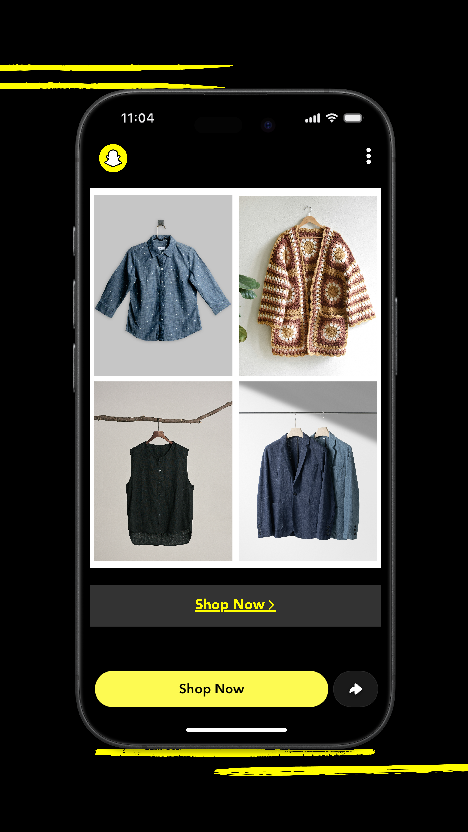
Hero (only image, static post): Snap for Business official Commerce Power Pack key art: https://images.ctfassets.net/inb32lme5009/5OIGBGDqmUSuDiLviLoPua/efa35d3968bb2991d33b5ad840c1c7c9/PERFORMANCE_SUMMIT_9x16_Tile.png
Source: https://forbusiness.snapchat.com/blog/commerce-power-pack (Snap for Business official blog, published Sept 10, 2026) Author: Snap Inc. / Snapchat for Business License: Officially cleared — Snap's own campaign asset hosted on Snap for Business's own CMS (Contentful), pulled directly from the blog post that is this idea's primary source

Visual Direction (for the design step)
Hero image: Snap's own Commerce Power Pack campaign key art: a glowing iPhone mockup floating on a pure black canvas, screen open on the Dynamic Product Ads catalog inside Snapchat (four real clothing product tiles, a yellow underlined 'Shop Now' link and a solid yellow 'Shop Now' pill button with a share icon at the bottom), framed top and bottom by Snap's own bold yellow gestural paint strokes. This is literally the ad product the 22% CPA stat is about, sourced directly from forbusiness.snapchat.com/blog/commerce-power-pack. Vertical 4500x8000px original, downloaded and visually inspected pixel by pixel.
Alt image queries: Snapchat Dynamic Product Ads Sponsored Snaps interface screenshot | Snap Inc Commerce Power Pack press image | Snapchat Ads Manager Value Optimization screenshot Snap newsroom | Snap Spend Smarter holiday campaign 2026 key art
Color mood: teal-accent energy (Growth Marketing & Branding pillar mood)
Symbol corner: top-right (transparent white Rarity symbol)
Logo (CTA slide): single static card, no separate CTA slide; save and share close lives in the caption, not on the art

Rights / Sensitivity
Hero image is an official Snap for Business asset pulled directly from the blog post that is this idea's own primary source (forbusiness.snapchat.com/blog/commerce-power-pack), hosted on Snap's own Contentful CDN (images.ctfassets.net/inb32lme5009/...). Verified by downloading the file directly (HTTP 200, image/png, 4500x8000px, far above the 1600px floor) and visually inspecting the actual pixels, not just alt text or a search caption. No interactive Chrome browser was available in this session, so URL resolution and visual verification were done via direct HTTP fetch plus source-page fetch (WebFetch) instead, per the fallback the task allowed; no image URL here was ever taken from a search-results thumbnail or a pinimg.com link. No real, identifiable private individual appears in the frame (it is Snap's own product and app graphic), so there is no editorial-model licensing concern. Credit on the card: Snap Inc. / Snapchat for Business.
Next step: run rarity-ig-designer on this brief to build the EN, ES, and PT art with rarity-ig-designer.

